**Class Diagram**

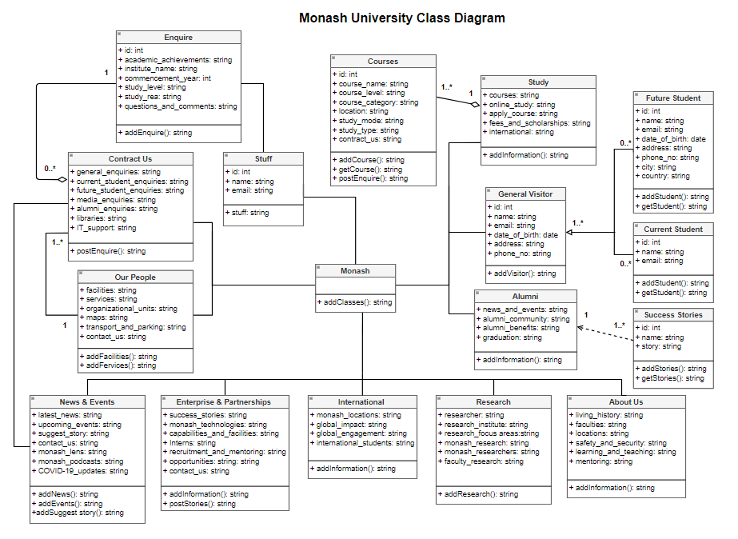

**Figure: Class diagram of Monash University**